GARIMA UPPAL(CU240251618)

COMPUTER VISION LABSHEET 3
Experiment No. 3

Implementation and Analysis of Spatial Filtering Techniques using Low-Pass and High-Pass Filters

Aim
To implement and analyze spatial domain filtering techniques using low-pass and high-pass filters for image smoothing, noise reduction, edge enhancement, and feature preservation using Python and OpenCV.

Purpose
Spatial filtering is one of the fundamental operations in digital image processing. It enhances image quality by modifying pixel values based on their neighboring pixels.
Low-pass filters are primarily used to reduce noise and smooth images, whereas high-pass filters emphasize edges, fine details, and abrupt intensity changes, which are important for feature extraction and object recognition.
In this experiment, different spatial filtering techniques are applied to real-world image data and their effects on image quality, edge preservation, and noise removal are analyzed.
Spatial filtering is useful as a preprocessing step in computer vision applications such as medical imaging, surveillance, remote sensing, and autonomous systems.

Prerequisites
- Basic knowledge of digital image processing
- Familiarity with Python programming
- Python libraries: OpenCV (cv2), NumPy, and Matplotlib
- Understanding of image kernels and convolution operations
- Jupyter Notebook, Google Colab, or Visual Studio Code

Steps
- Import the required libraries and load a grayscale or color image for processing.
- Display the original image and analyze its visual characteristics.
- Apply Gaussian Blur to reduce image noise while preserving important structures.
- Apply Median Filtering to remove impulse (salt-and-pepper) noise from the image.
- Apply Average (Mean) Filtering and compare its smoothing performance with Gaussian filtering.
- Implement Laplacian Filtering to enhance image edges and fine details.
- Apply Sobel Edge Detection in both horizontal and vertical directions to detect image gradients.
- Compare the outputs of different low-pass and high-pass filters in terms of noise reduction, edge preservation, and computational performance.
- Display the original and filtered images along with suitable observations highlighting the strengths and limitations of each filtering technique.
- Interpret the results and discuss the applications of spatial filtering in real-world computer vision systems.

PSEUDOCODE

START

  - Import OpenCV, NumPy and Matplotlib.

  - Read the input image in grayscale.

  - Display the original image.

  - Add salt-and-pepper noise to the image for demonstrating impulse-noise removal.

  - Apply Gaussian Blur to the noisy image.

  - Apply Median Filtering to the noisy image.

  - Apply Average (Mean) Filtering.

  - Apply Laplacian Filtering to detect edges and fine details.

  - Apply Sobel filtering in the X direction to detect horizontal intensity changes.

  - Apply Sobel filtering in the Y direction to detect vertical intensity changes.

  - Combine the Sobel X and Sobel Y results to obtain overall edge information.

  - Display the original, noisy and filtered images.

  - Compare noise reduction, smoothness,
edge preservation and detail enhancement.

  - Write observations and conclusion.

END

PYTHON PROGRAM
import cv2
import numpy as np
import matplotlib.pyplot as plt

# Step 1: Read the image
image = cv2.imread("input.jpg", cv2.IMREAD_GRAYSCALE)

if image is None:
print("Error: Image not found.") exit()

# Step 2: Display the original image plt.imshow(image, cmap="gray") plt.title("Original Image") plt.axis("off")
plt.show()

# Step 3: Apply Gaussian Blur gaussian = cv2.GaussianBlur(
image, (5, 5),
0
)

# Step 4: Apply Median Filter median = cv2.medianBlur(
image, 5
)

# Step 5: Apply Average / Mean Filter average = cv2.blur(
image, (5, 5)
)

# Step 6: Apply Laplacian Filter laplacian = cv2.Laplacian(
image, cv2.CV_64F
)

laplacian = cv2.convertScaleAbs( laplacian
)

# Step 7: Apply Sobel X sobel_x = cv2.Sobel(
image, cv2.CV_64F, 1,
0,
ksize=3
)

sobel_x = cv2.convertScaleAbs( sobel_x
)

# Step 8: Apply Sobel Y sobel_y = cv2.Sobel(
image, cv2.CV_64F, 0,
1,
ksize=3
)

sobel_y = cv2.convertScaleAbs( sobel_y
)

# Step 9: Display all results plt.figure(figsize=(10, 8))

plt.subplot(2, 3, 1) plt.imshow(image, cmap="gray") plt.title("Original") plt.axis("off")

plt.subplot(2, 3, 2) plt.imshow(gaussian, cmap="gray") plt.title("Gaussian") plt.axis("off")

plt.subplot(2, 3, 3) plt.imshow(median, cmap="gray") plt.title("Median") plt.axis("off")

plt.subplot(2, 3, 4) plt.imshow(average, cmap="gray") plt.title("Average") plt.axis("off")

plt.subplot(2, 3, 5) plt.imshow(laplacian, cmap="gray") plt.title("Laplacian") plt.axis("off")

plt.subplot(2, 3, 6) plt.imshow(sobel_x, cmap="gray") plt.title("Sobel X") plt.axis("off")

plt.tight_layout() plt.show()

# Display Sobel Y separately plt.imshow(sobel_y, cmap="gray") plt.title("Sobel Y") plt.axis("off")
plt.show()

CODE EXPLANATION

Image Reading
cv2.imread("input.jpg", cv2.IMREAD_GRAYSCALE)
Reads the input image as a grayscale image. Each pixel represents an intensity value from dark to bright.

Gaussian Filter
cv2.GaussianBlur(image, (5, 5), 0)
Applies Gaussian smoothing. It reduces noise and gives a smoother image while generally preserving important structures better than simple averaging.

Median Filter
cv2.medianBlur(image, 5)
Replaces each pixel with the median value of its neighborhood. It is particularly useful for removing salt-and-pepper noise.

Average Filter
cv2.blur(image, (5, 5))
Replaces each pixel using the average of the neighboring pixels. It smooths the image but can blur edges.

Laplacian Filter
cv2.Laplacian(image, cv2.CV_64F)
Uses the second derivative of image intensity to highlight rapid intensity changes, so edges and fine details become prominent.

Sobel X
cv2.Sobel(image, cv2.CV_64F, 1, 0, ksize=3)
Calculates the intensity gradient in the X direction. It is mainly useful for detecting changes associated with vertical edges.

Sobel Y
cv2.Sobel(image, cv2.CV_64F, 0, 1, ksize=3)
Calculates the intensity gradient in the Y direction. It is mainly useful for detecting changes associated with horizontal edges.

FILTER COMPARISON

Filter | Type | Main Use | Main Limitation
Gaussian | Low-pass | Smoothing and noise reduction | Can blur fine details
Median | Low-pass / nonlinear | Salt-and-pepper noise removal | Can remove small details
Average | Low-pass | Basic image smoothing | Blurs edges strongly
Laplacian | High-pass | Edge and fine-detail enhancement | Sensitive to noise
Sobel X/Y | High-pass / gradient | Directional edge detection | May need thresholding/post-processing

ACTUAL OUTPUT
The following results were generated by actually running the spatial filtering operations on a real grayscale photograph. A controlled salt-and-pepper noise sample was also added so that the Median Filter's noise-removal behavior could be observed clearly.
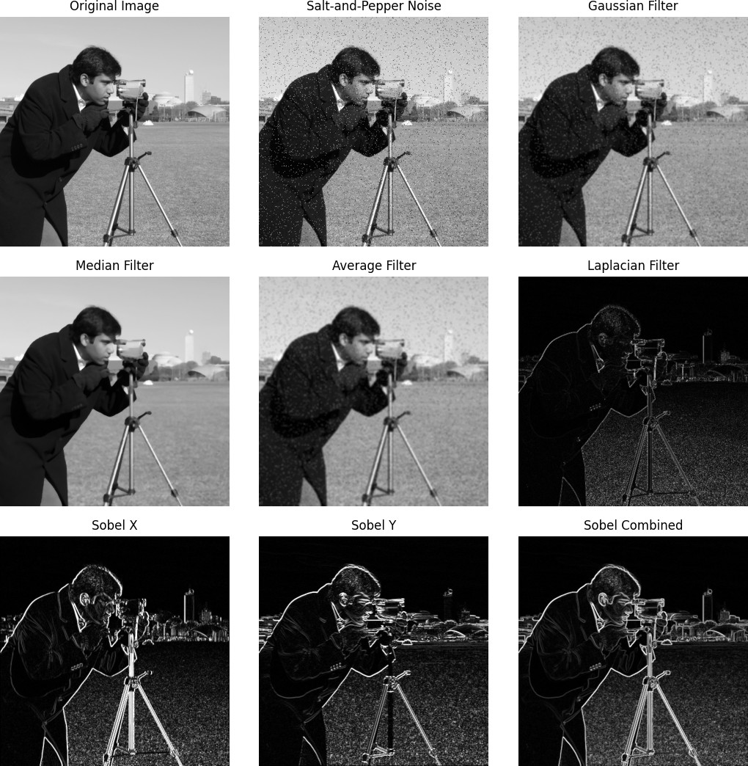

Figure: Original image, salt-and-pepper noise, Gaussian, Median, Average, Laplacian and Sobel filtering results.

Output Observations
- Gaussian Filter: The image becomes smoother and high-frequency noise is reduced.
- Median Filter: Salt-and-pepper noise is reduced effectively while important boundaries are reasonably preserved.
- Average Filter: The image becomes smooth, but edges may become more blurred than with Gaussian filtering.
- Laplacian Filter: Fine details and sharp intensity changes are highlighted.
- Sobel X: Directional intensity changes are highlighted in the X direction.
- Sobel Y: Directional intensity changes are highlighted in the Y direction.
- Overall: Low-pass filters are mainly useful for smoothing and noise reduction, while high-pass and gradient operators are useful for edge and feature extraction.

QUESTIONS AND ANSWERS

Q1. What is spatial filtering? How is it used in digital image processing?
Spatial filtering is an image-processing technique in which the value of a pixel is modified using the pixel values in its neighborhood. A small matrix called a kernel or filter mask is moved over the image.
For every position, the kernel combines neighboring pixel values to produce a new output pixel.
Spatial filtering is used for image smoothing, noise reduction, sharpening, edge detection and feature enhancement.

Q2. Differentiate between Low-Pass Filters and High-Pass Filters with suitable examples.
A Low-Pass Filter allows slowly changing intensity information to remain and reduces high-frequency information. It is mainly used for smoothing and noise reduction. Examples are Gaussian, Average and Median filters.
A High-Pass Filter emphasizes rapid intensity changes such as edges and fine details. Examples include Laplacian and Sobel operators.
In simple words: Low-pass → smooths the image. High-pass → highlights edges and details.

Q3. Compare Average Filter, Gaussian Filter, and Median Filter based on their working principles and applications.
Average Filter: It calculates the arithmetic mean of neighboring pixels. It is simple and useful for basic smoothing, but it can blur edges.
Gaussian Filter: It uses a Gaussian-weighted neighborhood, giving more importance to pixels near the center. It is commonly used for noise reduction and smoothing while retaining important structures better than simple averaging.
Median Filter: It sorts the neighboring pixel values and selects the middle value. It is especially effective for impulse or salt-and-pepper noise and can preserve edges better than average filtering.

Q4. Why is the Median Filter particularly effective for removing salt-and-pepper noise?
Salt-and-pepper noise contains very bright and very dark pixels that appear as isolated points. The median filter replaces a pixel with the median value of its neighborhood.
Extreme values such as 0 and 255 do not affect the median as strongly as they affect an arithmetic mean. Therefore, isolated noisy pixels can be removed while useful boundaries are relatively preserved.
This is why the Median Filter is widely used for salt-and-pepper noise removal.

Q5. Explain the role of convolution kernels in spatial filtering.
A convolution kernel is a small matrix containing numerical weights. It is moved over the image, and the kernel values are combined with the corresponding image pixels.
The resulting value becomes the new pixel value. For example, a simple 3 × 3 averaging kernel is:
1/9 1/9 1/9 1/9 1/9 1/9 1/9 1/9 1/9
Different kernels produce different effects such as smoothing, sharpening or edge detection.

Q6. What is the purpose of the Sobel and Laplacian operators in edge detection?
The Sobel operator calculates image intensity gradients in specific directions. Sobel X detects changes in one direction and Sobel Y detects changes in the other direction. They are useful for detecting edges and object boundaries.
The Laplacian operator uses the second derivative of image intensity. It responds strongly to rapid changes and therefore highlights edges and fine details.
Both are useful for feature extraction and boundary detection.

Q7. Why are filtering operations considered an essential preprocessing step in computer vision?
Filtering is often used before later computer-vision operations because raw images may contain noise, unwanted fine variations or other disturbances.
Filtering can: 1. Reduce image noise. 2. Smooth unwanted variations. 3. Improve edge quality. 4. Highlight important structures. 5. Prepare the image for segmentation, detection or feature extraction.
Therefore, suitable filtering can make later computer-vision algorithms more reliable.

Q8. Discuss the trade-off between image smoothing and edge preservation during filtering.
Smoothing reduces noise and unwanted variations, but excessive smoothing can also remove useful edges and fine details.
For example, a strong Average or Gaussian filter can make an image very smooth but may blur object boundaries. On the other hand, weaker smoothing preserves more detail but may leave more noise.
Therefore, the filter type and kernel size should be selected according to the application. The aim is to reduce unwanted noise while preserving important image structures.

Q9. Mention four real-world applications where spatial filtering techniques are widely used.
- Medical Imaging: Filtering can reduce noise and improve the visibility of structures in medical images.
- Surveillance: Filtering can improve camera frames before object or motion detection.
- Remote Sensing: Satellite and aerial images can be filtered to reduce noise and enhance useful structures.
- Autonomous Systems: Cameras used in robots and vehicles can use filtering as preprocessing before detecting lanes, objects and boundaries.

Q10. Compare spatial domain filtering with frequency domain filtering in terms of implementation and practical applications.
Spatial-domain filtering works directly on image pixels using kernels or neighborhood operations. It is generally straightforward to implement and is very useful for common operations such as smoothing, sharpening and edge detection.
Frequency-domain filtering first transforms the image into frequency components, modifies selected frequencies, and then transforms the result back.
Spatial filtering is convenient for local operations, while frequency-domain filtering is useful when the problem is better described by controlling low- and high-frequency components.

FINAL OBSERVATION
- Gaussian filtering produced a smooth image and reduced high-frequency variations.
- Median filtering was especially effective against the added salt-and-pepper noise.
- Average filtering also smoothed the image but caused noticeable edge blurring.
- Laplacian filtering emphasized fine details and sharp intensity changes.
- Sobel X and Sobel Y detected directional image gradients and edges.
- The experiment shows that filter selection depends on whether the goal is noise reduction, smoothing, edge enhancement or feature extraction.

CONCLUSION
The experiment successfully demonstrated spatial filtering techniques using Python and OpenCV. Gaussian, Median and Average filters were studied for smoothing and noise reduction, while Laplacian and Sobel operators were used for edge and fine-detail enhancement. The results show that no single filter is best for every task. The appropriate filter should be selected according to the type of noise, required smoothness and amount of edge preservation needed.

